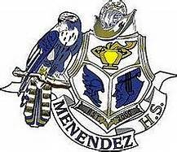
Pedro Menendez High School
SAC Meeting Agenda
Thursday, February 18th – 8:00 am
Microsoft Teams/PMHS Library

- Welcome and Sign-In
- School Updates Dr. Carmichael
  - Arts: Drama Performance for teachers- it was recorded and posted
All High School teachers met last week- there will be NO prom this. “Social Event” focusing on seniors. Senior awards- possibly by appointment/ athletic field
Senior sponsors are looking at grad bash
Coach Matt Potak- head FB coach-full support
Matt McCool- Athletic Director
Wrestlers- runners up, advancing to sate as a team
Girls soccer back to back district wins
Boys won districts- regional final match 2/23/2021
Students are scheduling now- hiring is based on the schedules created now, which is why there is limited scheduled changes at the start of the new school year
School counselors – Family crisis constantly due to covid
60 Distance Learners really struggling. Teachers who are assigned students to keep in contact with .
Next meeting tutoring plan, what to expect 2021-2022
- SAC Survey Review Waldrop
  - Updates/edits by SAC members
- Remarks from SAC members All Members
- Meeting adjournmen motion to busby, phillips 8:40am
Upcoming Meetings:

3/11/21 8:00am
4/15/21 8:00am 5/20/20 8:00am

