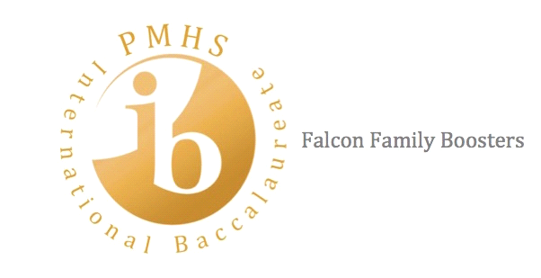
IB Falcon Family Booster Meeting
Minutes
November 21, 2019

- Call to order at 5:30 PM
- Attendees: Amy Newman, Jonathan Higgins, Jenny Holbrook, Tiffany Busby, Clay Carmichael, Jeanette Bratcher, Olivier Berdoyes, Holly Guyton, Jyoti Silvera, Christy Brackett, Charlene Beymer, Leigh Ann Concha, Bridget Carmichael, Jeanne Ryan, and Leila Wallut.
- Financial Summary Review (Tiffany Busby)
  - IB Dance Balance $2,228.55
  - Main IB Booster Balance: $4,764.87
- Fundraising:
  - Holiday wreaths can be ordered online (resend code)
  - Poinsettias
    - About 50% profit
    - Flyers out
    - First delivery date-December 4th
    - Possible second date to be announced
    - Consider IB Students for delivery volunteers and sign-up for parent volunteers.
  - Spirit Nights:
    - October: Chipotle: Did not make $300.00 but Chipotle donated ~$100.00
    - November: Zaxby’s, made $250.00
    - Next: January--discussed possible promoting the night with possible “Celebrity Scoop,” raffle for a free basketball game admission at school, etc.
- Field Trip
  - Jacksonville Iceman- sold tickets for hockey game-turnout lower than expected. Loss of $1,011.00 due to covering cost of charter bus
- Senior IB Banquet and mini-graduation: The White Room (above AIA Ale Works) payment complete.
  - Will need non-senior parents for volunteering

- IB Graduate Breakfast: Consider kid-to-kids feedback, video tape IB benefits, and place on website.
- Important Dates:
  - December 3,2019: Poinsettia order forms due
  - December 14, 2019: Hasting Christmas Parade: IB Float?
  - December 18, 2019 IB Coffee and Credential Breakfast for 2019 Graduates: Need Breakfast food and volunteers, starts at 8 am
  - January 9, 2020: High School Academy Showcase at World Golf Village
  - January 16, 2020: IB Pinning Seniors at 6:30 pm at PMHS
  - January 23, 2020: PMHS Academy Night at 5:30 pm
  - January 24, 2020: Medieval Times Field Trip for Sophomore IB and AVID
  - March 4, 2020: IB Cultural Fair
  - April 18, 2020: Graduation Bash/Seniors
  - April 24, 2020: Prom
  - May 1, 2020: IB Senior Lock-in
  - May 5-21, 2020: IB Testing
  - May 12, 2020: IB Banquet
- RTI: Mr. Higgins--For IB Struggling Students is in the planning stage
- IB vs Dual Enrollment: Mr. Higgins provided a handout comparing the two tracks
- IB Spirit Wear: Mr. Higgins—a Sports Corner online store will be open for about 10 days
- IB Family Booster Web Site: Mr. Higgins--Transfer WordPress information to PMHS site. Boosters to drop the WordPress site.
- IB Pinning Ceremony will need volunteers and food
- Next meeting to be announced
- Meeting adjourned: 6:30 pm
IB Contact Information:
PMHS IB Family Booster
600 State Road 206 West
St. Augustine FL, 32086
e-Mail: PMHSIBBoosters@gmail.com

