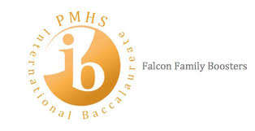 | IB Boosters  Courtesy Notice of Upcoming Dates/Events  February 20, 2020
February 21, 2020
USF Engineering Expo Field Trip

February 22, 2020 at 10 am to 3 pm
FAMU-FSU College of Engineering Open House
https://www.eng.famu.fsu.edu/index.php/event/open-house/2020

Saturday, February 22, 2020
PMHS Car Show 10:00am-1:30pm
PMHS Track

Weeks of February 24 – March 9
Spanish IV and Ab. Inititio II IA Testing

March 4, 2020
PMHS Cultural Fair
Courtyard

March 6, 2020
-Sophomores-
Medieval Times Field Trip

March 11 & 1 2, 2020
Spring Dance Program
PMHS Auditorium

March 12, 2020
End of Third Quarter

March 13 – March 23, 2020
Spring Break (for students)

Thursday, March 26, 2020, 5:30 pm
March IB Boosters Meeting
Media Center

Saturday, March 28, 2020
Falcon 5K Run

April 18, 2020
-Seniors-
Grad Bash

April 24, 2020
Prom
(lower classmen must be invited by an upper classman)

April 25, 2020, 10 am to 4 pm
Earth Day Celebration at Washington Oaks Gardens State park

August 31, 2020
Bright Futures Scholarship Application Deadline for 2020
Students must apply for the scholarship by submitting the Florida Financial Aid Application (FFAA) no later than August 31 after high school graduation (you cannot receive this scholarship if you do not apply). The FFAA application opens on October 1st of each year.

