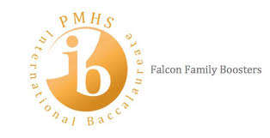

AGENDA
Thursday, November 21, 2019

- Greetings/Introductions (Amy Newman)

- Previous Meeting Minutes (Jyoti Silvera)

- Treasurer’s Report (Tiffany Busby)

- Fundraising Activities (Amy Newman and Jonathan Higgins)
- Spirit Nights
- Poinsettia Fundraiser
- Holiday Wreaths

- IB Spirit Wear online store (Jonathan Higgins)

- RTI Process (Jonathan Higgins)

- December 18th Welcome Back IB Grads Breakfast (Jonathan Higgins)

- Adjourn

