PMHS Athletic Booster Club Scholarship
In Honor of ReAnna Green

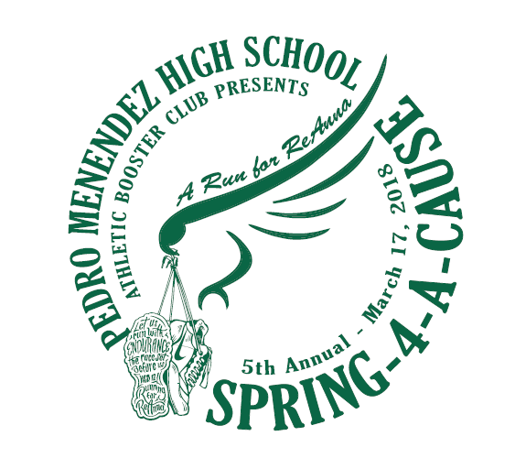
On March 17, 2018, PMHS Athletic Booster Club hosted our 4th Annual Spring 4-A-Cause 5k. In 2016, we elected to dedicate this run to a former Falcon, Miss ReAnna Greene. ReAnna was a 2007 PMHS graduate who tragically lost her life to Domestic Violence in April 2015. ReAnna grew up in St. Augustine and after graduation went on to earn her BSN at UCF in 2011; after that, she moved to Baltimore to work at the R. Adams Cowley Shock Trauma Center. At the time of her passing, ReAnna was enrolled in a Doctorate program at the University of Maryland where she was also a teaching assistant.
In honor of ReAnna, the Pedro Menendez High School Athletic Booster Club is proud to be able to help a student athlete succeed in their pursuit of a nursing degree. In order to do our part, we are offering a $1,000 scholarship* to a deserving student. A deserving student must meet ALL of the following criteria in order to be considered:

- 2017 PMHS graduate pursuing a nursing degree (ASN/ BSN)
- Previous or current student athlete of any PMHS sport for at least 2 years
- Must include Junior and Senior years
- Provide transcripts indicating a minimum 3.0 GPA- unweighted
- Provide proof of 75 hours of documented community service
- Provide 2 Letters of Recommendation (Teacher and/or Coach)

Additionally, a deserving student must also submit an effective essay detailing:
Why are you passionate about nursing?
A deserving student will submit their typed essay, along with supporting required documents to the Athletic Secretary, Mrs. Telisha Taylor by: April 28, 2017.
The recipient of this scholarship will be notified during the Senior Awards Ceremony on May 11, 2017.
*Scholarship funds are equally divided between Fall and Spring semesters at student’s chosen college.

