Making Online Payments with Charms
- Access Charms' website.
- Click and select Parents/Students/Members.
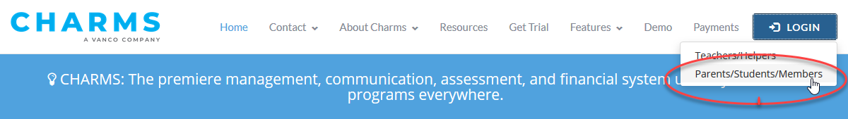
- Enter your school code PedroMHSBand and then click .
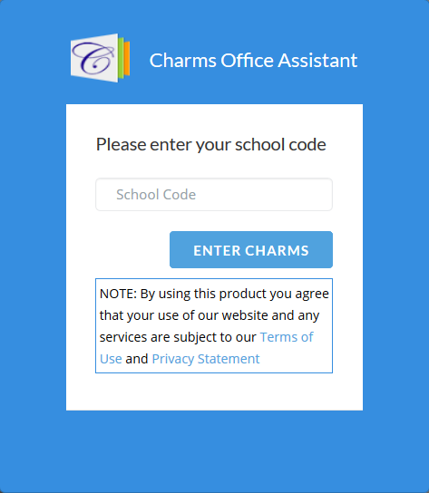
- For Student Area Password, type your password, and then click Enter. If this is your first time using Charms the password will be your child’s school student ID (use numbers ONLY).
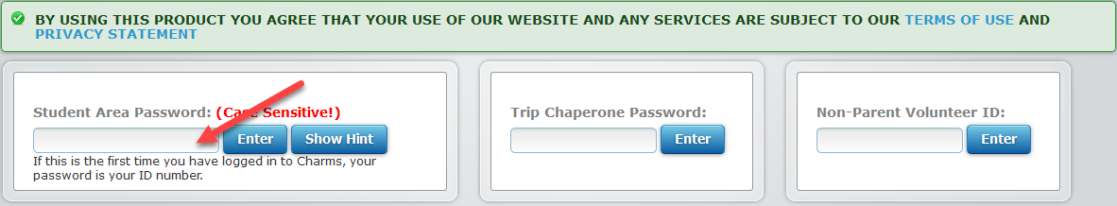
- Click Finances. 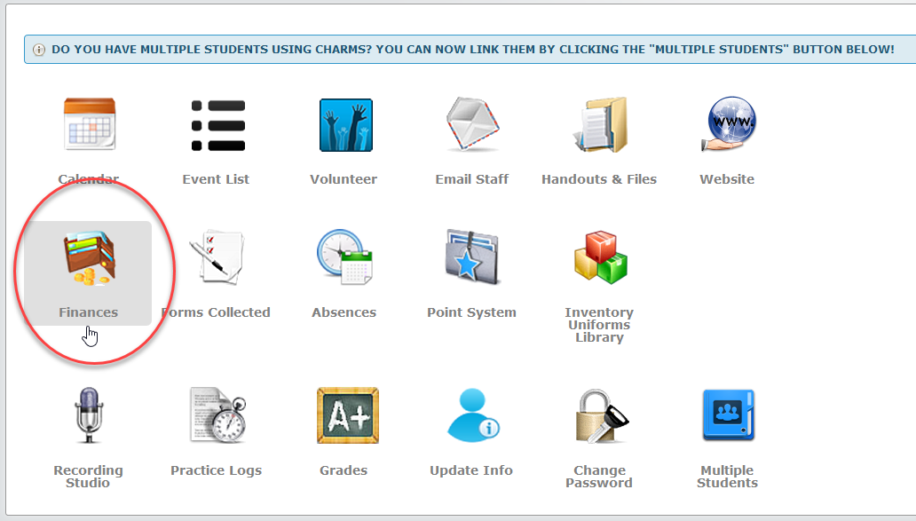
- Make the applicable credit card payment.
  - For a Miscellaneous Ledger Payment, in the Student Miscellaneous Ledger Detail section, click Make Miscellaneous Payment.
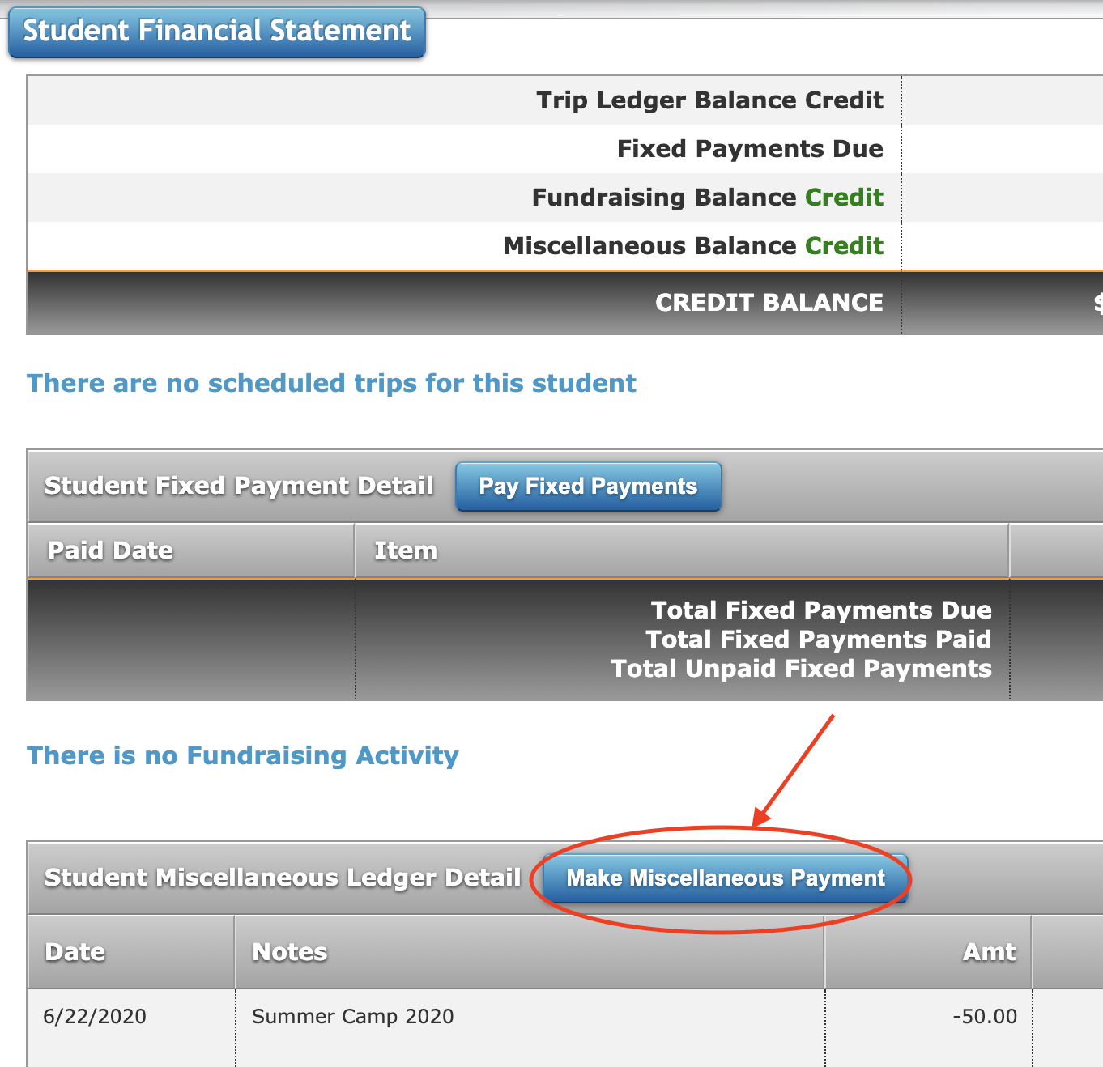
- Verify the Total to be Charged to Card is correct, add you credit card information, and then click Start Payment. Note our band will use AffiniPay for credit card payments. If you have any issues email bandboosterspmhs@gmail.com .
